The Yiddish Avant-Garde

The Yiddish avant-garde represented a second generation of inventors of a new, independent Jewish culture. The first generation, which had been involved in the haskalah (enlightenment) movement, promoted Zionism, the revival of Hebrew as a literary language and, partly, its assimilation within everyday culture. In contrast, the second generation aimed at the emancipation of a secular culture of the Diaspora with Yiddish as a prime token of its identity. Yiddish was recognized as the second language of Jewish culture on par with Hebrew at the Czernowitz Language Conference of 1908.

The movement was particularly active in the former “Ansiedlungsrayon” of the Russian Empire (Poland, Ukraine, and Belarus), but also had ties to Romania and other countries. The main centres of the network were Kiev, St. Petersburg, Minsk, Kharkov, Riga, Odessa, Moscow, Łódź, and Warsaw, but also New York, Berlin, and Paris. Its most prominent representatives were Nathan Altman, Boris Aronson, Marc Chagall, Mark Epshteyn, Dovid Hofstheyn, Isaachar Ber Ryback, Sarah Shor, Alexander Tyschler, and Mikhail Yo/Yoffe.

In the first phase of the existence of the Yiddish avant-garde, An-Sky [Shloyme Zanvl Rappoport], author of the famous play The Dybbuk or Between Two Worlds, initiated the ethnographic expeditions into Ansiedlungsrayon along the Dniepr in 1911 and 1915–16. They were documented with photographs and drawings by El Lissitzky and Ryback and resulted in Jewish folkloristic and oriental motives in the designs of poetry and children books. After the October Revolution, the Yiddish avant-garde briefly flourished, supported by official organisations such as the Kultur-Lige (Cultural League), founded in Kiev in 1918, which had branches in Białystok, Odessa, and Vilna. In 1920, when several Jewish artists emigrated from the Soviet Union, they founded another branch independent from the Russian communist party structures in Warsaw.

The main formations of the Yiddish avant-garde were the Kiever Grupe (Kiev Group, 1918–20), which split into the Moscow group with the Shtrom magazine (Current, 1922–24), the Berlin group with the periodical Milgroim/Ribbom (Garnet, 1922–24, published in Hebrew concurrently) and the New York group Inzikh (Within Oneself, 1920–39). The publication of the magazine Yung-Yidish (1919) marks the first stage of the Warsaw Yiddish avant-garde, culminating in the almanac Khalyastre (The Gang, 1919-22, edited by Peretz Markish) and the activities of the group of the same name (1919–24). The second phase of the movement included the magazine Ringen (Rings, 1921–22, edited by Melekh Ravitch), and the final one was marked by the activities of the “great three”—Markish, Ravitch, and Uri Tsvi Greenberg. The latter also edited their own magazine—Albatros (1922–23, first Warsaw, then Berlin). Warsaw acquired the status of the European centre of Yiddish literature, with Paris and Berlin serving as its satellites. The literature of the Diaspora expressed the atrocities of World War I, the pogroms and revolutions. The magazines Ing-Yidish and Albatros broke the biblical ban on images and served the avant-garde’s integration of visual and literary media with a new kind of typography, which was unprecedented in other publications of the movement.

The Young Yiddish group (1919-23), which included Jankiel/Yankl Adler, Moyshe Broderzon, Marek Szwarc, and several female artists (among them Pola Lindenfeld) created a developed institutional network consisting not only of a magazine but also of a series of illustrated books and periodicals such as Heftn far Literatur un Kunst (Books for Literature and the Arts, 1919) and S’Feld (Field, 6 issues, 1919-23), exhibitions in Łódź, Warsaw, and Białystok, musical events, and theatre performances.

The tradition of artistic Yiddish theatres and cabarets originates in the performances by Graham Goldfaden in Jassy, Romania, in 1876, including folk songs and the Purim-shpiel of Biblical motifs, which gained popularity, but were disregarded among intellectuals who called it shrund (garbage) and were forbidden by the Tsar in 1878-1905. Important later theatres included The Vilnius Group (1916-17), the Warszawer Idiszer Kunsttheater (1922–24, 1926–27, 1938–39), the experimental Jung Theatre (1932–37), and the Folks und Jungt Theater (1937-39). In Łódź, Broderzon, his wife Miriam, Yekheskl Moyshe Nayman/Neuman, Yitskhok/Vincent Brauner, and Henryk Kohn founded the puppet theatre Chad Gadje (Billy-Goat, 1922-32) and the revolutionary café-théâtre Ararat (1927-39), which survived until the outbreak of World War II.

The Yiddish avant-garde was far from homogeneous and reflected the far-reaching discussions on so-called Jewish art. On the one hand, the Paris-based magazine Makhmadim (Precious Ones, 1911-12, edited by Marek Szwarc, Josif Chaikov, and Isaac Lichtenstein) promoted the imitation of the synagogue and oriental ornamentation, while on the other, the most eminent representatives of the so-called Jewish expressionism—Nathan Altman, Marc Chagall, Ludwig Meidner, and Jacob Steinhardt—abandoned copying folklore patterns for the sake of stylisation and individual traits following cubist deformation and orphism. However, the Yiddish avant-garde also adapted other styles and cooperated with several avant-garde groups in Russia, Poland, Romania, Germany, and France (see also POLISH EXPRESSIONISM, POLISH CONSTRUCTIVISM, HENRYK BERLEWI, TERESA ŻARNOWER).

After the 1922 congress and exhibition of Dadaists and Constructivists in Düsseldorf and the 1923 exhibition of Young Art in Łódź, international constructivists of Jewish origin were only rarely identified with Yiddish culture. The main tendencies of INTERNATIONAL CONSTRUCTIVISM with its non-personal, rational visual language were Mechano-Facture by Henryk Berlewi and the Prouns by El Lissitzky. The last major platforms of Yiddishism with roots in avant-garde culture were the groups Yung-Vilne (Young Vilna, 1929–39) and the New York based Inzikh group (until 1939). In the 1930s they changed from avant-garde tendencies to a concentration on social issues, but continued to publish Yiddish poetry.

References and further reading:

Ruth Apter-Gabriel, Tradition and revolution. The Jewish Renaissance in Russian Avant-Garde Art 1912-1928, Jerusalem: Muzeon Yisrael, 1987.

Marina Dmitrieva (ed) et al., Jüdische Kulturen im Neuen Europa. Wilna 1918-1939, Wiesbaden: Harassowitz, 2004.

Rachel Ertel (ed.), Khaliastra, la bande. Revue littéraire Varsovie 1922 –Paris 1924, Paris: Lachenal et Ritter, 1989.

Benjamin Harshaw (ed.), The Moscow Yiddish Theater. Art on Stage in the Time of Revolution, New Heaven: Yale University Press, 2008.

Nathalie Hazan-Brunet/Ada Ackerman (eds), Futur antérieur: L'avant-garde et le livre yiddish (1914–1939), Paris: Flammarion, 2009.

Lidia Głuchowska, From Transfer to Transgression. The Yiddish Avant-Garde – a Network within the Universal Network of the International Movement or a Complementary One? Cahiers de la Nouvelle Europe, Sept. 2012 (forthcoming).

Hillel Kazowsky, The Artists of the Kultur-Lige, Jerusalem: Gesharim, 2003.

Hillel Kazowsky, (ed.), Kultur-Lige. Artistic Avant-Garde of the 1910s and 1920s. Kiev: Duch i Litera, 2007.

Jerzy Malinowski, The ‘Yung Yiddish’ (Young Yiddish) Group and Jewish Modern Art in Poland, 1918–1923, Polin 6 (1991), pp. 223–230

Gilles Rozier, Moyshe Broderzon: Un écrivain yiddish d’avant-garde, St. Denis, Fr., 1999).

Yung-yidish, in: http://www.yivoencyclopedia.org/article.aspx/Yung-yidish

Suggested images:

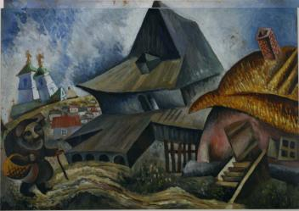
- Issachar Ber Rybback, Village scene, Oil on Cardboard, 1918, Ryback Museum - Bat Yam
http://www.comite-ryback.org/Catalogue_Raisonne_Details.php?id=catalogueRaisonne

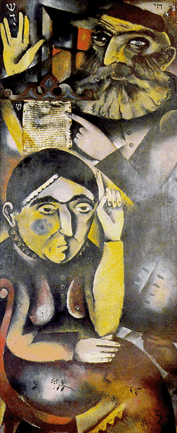

- Jankiel Adler, My Parents, Oil on Wood, c. 1921, Museum of Art, Łódź
http://www.eilatgordinlevitan.com/krakow/krkw_pix/art/070108_31_b.gif&ir=http://www.eilatgordinlevitan.com/krakow/krkw_pages/krkw_art.html&ig=http://t1.gstatic.com/images?q=tbn:ANd9GcShXbs4Hhny23ued9TXh6Fy2ccCQOVZddkqDSaCfM1h2s_0y6o2u601mk0&h=600&w=245&q=Jankiel+Adler+Moi+Rodzice&babsrc=TB_ss

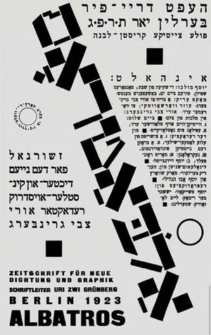
3. Henryk Berlewi, Cover of the almanac Albatros 3–4, Berlin 1923, lithography, Maison de la culture yiddish Bibliothèque Medem, Paris.

http://jewschool.com/wp-content/uploads/2008/02/300_image014.jpg&ir=http://jewschool.com/2008/02/24/13165/i-got-this-new-philosophy-zayde-its-called-mechano-faktura/&ig=http://t3.gstatic.com/images?q=tbn:ANd9GcSTHXo9D_3V4f152hvJKPJhlHxP9h4eEIr6lVhxzDfE9yIZxIH0ZlZ86CVV&h=476&w=300&q=henryk+berlewi&babsrc=TB_ss

